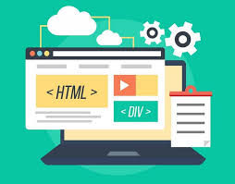

REPORT ON

TODO APP CREATIOn

DONE BY

(TEAM)

Sailada Charan Kumar

Penta Shanmukh

Pudi Eswar Rao

Reddi Sirisha

INTRODUCTION **List App** is a kind of ap that ToDo List App is a kind of app that generally used to maintain our day-to-day tasks or list everything that we have to do, with the most important tasks at the top of the list, and the least important tasks at the bottom. It is helpful in planning our daily schedules. We can add more tasks at any time and delete a task that is completed.

Features:

In this version of the ToDo list, the user will be getting four options:

Create (add) a new task or adding a new ToDo in the ToDo List App.

See all the tasks or View all the ToDos that were added to the app.

Delete any ToDo from the list of ToDos.

Exit from the app

PURPOSE OF TODO APP

The benefits of using a daily to-do list range from higher productivity to better mental health. It might also have a major impact on your personal life, as you can be more productive at work and enjoy your personal time without stress. Regularly creating a list can help you track your short-term goals, ideas, and, accomplishments, while having an overall positive effect on your career. Below are some benefits of setting up a daily to-do list:

Increases productivity

At work and at home, having a to-do list may help you prioritize your work and personal tasks. This allows you to organize and complete the most crucial tasks first. To-do lists can be used to improve time management because all of your tasks are laid out clearly in advance. You can more easily decide what to do after IT

Provides motivation

Too many tasks to remember can be overwhelming, but with the proper motivation, you can accomplish more and reduce stress. Having a to-do list makes it easier to organize everything that you want to accomplish in the day so that you can start fresh the next. Physically crossing items off a list can also increase motivation.

PROBLEMS OR ISSUES WITH TODO APP

Not simple enough. It’s not about the design but more about the experience. If I have something in mind and want to write it down as a to do item, I want to do it right away. I don’t like that I have to pull out my phone and find the to-do app and click here and there and type. I always have a notebook and a pen on my desk (either at work or home), so I just pick up the pen and write down anything immediately. Also, I try to keep my phone away (in my bag) during my work time. If I open my phone, there are too many other distractions. Maybe the problem is a general one to most digital products.

“To Do” apps cannot give me the fantastic feeling of accomplishing something. We will feel more or less pressure if there are a lot of tasks need to finish. Meanwhile, we feel pretty good about accomplishing something. I love the feeling that I can use my pen and cross-over or line out the task I accomplished. Though some apps try to mimic this human behavior (swipe to delete the items etc.), none of them do this very well. Something that is more physical can give us more tangible good feelings.

Proposed solution

Set some constraints on social media, apps, and online distractions.

(My research indicates that users are heavily distracted in this area.)

Manage time on tasks, then validate time spent.

(My research shows that users often lose track of their time and delay work.)

Generate a report showing where we spend our time on tasks.

(Users want to know better how their time is spent and how to improve their efficiency.)

Make it easy for users to manage todo lists, track time and set constraints in one place.

(Users typically depend on different tools to help organize tasks and track time.)

Add the ability to prioritize tasks via deadline.

(Users wish to prioritize todos mainly based on deadlines.)

Add the ability to easily add tasks and to search todo lists.

(Users want be able to easily find todo items.)

Reduce distractions from mobile by allowing device settings to be synced from desktop.

(Users want to have data sync cross platform.)

It’s very tempting to include many functions in our quest to help users, but all those functions might not lead us toward the target we’re aiming for. The Moscow method helps to set the path of product planning and trim down the scope we need for a minimum viable product(MVP). The point is to get the product out for real-world testing so we can have feedback and continue iterating the product.

With social media and other easily accessible online distractions, it’s more difficult than ever for us to stay focused through the course of doing our tasks. In order to handle tasks more efficiently, we must learn to manage digital distractions. This app helps us when we don’t want to engage with these distractions and maintain boundaries at work. The app also provides reporting that will make us more aware of how we spend our time and more informed about how productive we are. As a result, we are able to more efficiently manage our tasks.

BLOCK DIAGRAM

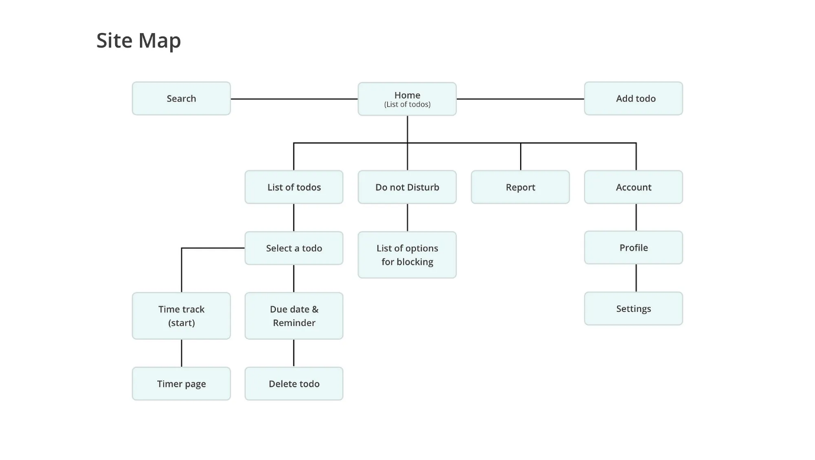

MY COMPLETE CODES OF HTML CSS JAVASCRIPT

My html code

<!DOCTYPE html>

<html lang="en">

<head>

<meta charset="UTF-8">

<meta name="viewport" content="width=device-width, initial-scale=1.0">

<title>Todo App JavaScript | </title>

<link rel="stylesheet" href="style.css">

<link rel="stylesheet" href="https://cdnjs.cloudflare.com/ajax/libs/font-awesome/5.15.3/css/all.min.css"/>

</head>

<body>

<div class="wrapper">

<header>Todo App</header>

<div class="inputField">

<input type="text" placeholder="Add your new todo">

<button><i class="fas fa-plus"></i></button>

</div>

<ul class="todoList">

<!-- data are comes from local storage -->

</ul>

<div class="footer">

<span>You have <span class="pendingTasks"></span> pending tasks</span>

<button>Clear All</button>

</div>

</div>

<script src="script.js"></script>

</body>

</html>

MY CSS CODE

*{

margin: 0;

padding: 0;

box-sizing: border-box;

}

body{

height: 100vh;

background-color:lightpink;

color:white;

}

.container{

position: relative;

max-width: 800px;

padding: 10px;

margin: 50px auto;

border: 2px solid white;

margin-top: 0px;

border-radius: 5px;

box-shadow: 0 2px 5px ;

background-color:rgba(255, 99, 71, 0.5);

}

.addTask{

width: 100%;

display: flex;

padding: 10px 0;

justify-content: center;

align-items: center;

}

.addTask > input[type="text"]{

width: 90%;

color: #333;

background: white;

padding: 10px;

font-size: 22px;

outline: none;

border-radius: 5px;

}

.addTask button{

margin: 0 10px;

background: #222;

color: #fff;

font-size: 18px;

text-transform: uppercase;

padding: 10px;

border: none;

outline: none;

border-radius: 5px;

cursor: pointer;

}

.notCompleted, .Completed{

margin: 5px 0;

padding: 20px;

}

h3{

font-size: 28px;

/*text-transform: uppercase;*/

text-align: center;

color: black;

}

ol{

list-style: none;

counter-reset: my-counter;

}

ol li{

width: 100%;

padding: 18px;

margin: 5px 0;

background: red;

font-size: 22px;

counter-increment: my-counter;

}

ol.Completed li{

background: #00ff62;

}

ol li::before{

content: counter(my-counter);

background: #231381;

width: 2rem;

height: 2rem;

border-radius: 50%;

display: inline-block;

line-height: 2rem;

text-align: center;

color: #fff;

margin-right: 0.5rem;

}

li button{

float: right;

padding: 5px;

font-size: 28px;

line-height: 28px;

margin-right: 15px;

background: none;

border: none;

outline: none;

cursor: pointer;

}

.home {

margin-top: 200px;

font-size: 30px; /*Increase the font size */

display: flex;

justify-content: center;

margin-right: 680px;

color:white;

}

/* Increase size and align the menu bar icon */

.menu-bar {

position: absolute;

top: 50px;

left: 50px;

font-size: 40px; /* Increase the font size */

cursor: pointer;

color:white;

}

/*.dropdown-content {

display: none;

position: absolute;

background-color: #f9f9f9;

min-width: 160px;

box-shadow: 0px 8px 16px 0px rgba(0,0,0,0.2);

z-index: 1;

}

.menu-bar:hover .dropdown-content {

display: block;

}

.dropdown-content a {

color: black;

padding: 12px 16px;

text-decoration: none;

display: block;

}

.dropdown-content a:hover {

background-color: #f1f1f1;

}*/

My js code :

*{

margin: 0;

padding: 0;

box-sizing: border-box;

}

body{

height: 100vh;

background-color:lightpink;

color:white;

}

.container{

position: relative;

max-width: 800px;

padding: 10px;

margin: 50px auto;

border: 2px solid white;

margin-top: 0px;

border-radius: 5px;

box-shadow: 0 2px 5px ;

background-color:rgba(255, 99, 71, 0.5);

}

.addTask{

width: 100%;

display: flex;

padding: 10px 0;

justify-content: center;

align-items: center;

}

.addTask > input[type="text"]{

width: 90%;

color: #333;

background: white;

padding: 10px;

font-size: 22px;

outline: none;

border-radius: 5px;

}

.addTask button{

margin: 0 10px;

background: #222;

color: #fff;

font-size: 18px;

text-transform: uppercase;

padding: 10px;

border: none;

outline: none;

border-radius: 5px;

cursor: pointer;

}

.notCompleted, .Completed{

margin: 5px 0;

padding: 20px;

}

h3{

font-size: 28px;

/*text-transform: uppercase;*/

text-align: center;

color: black;

}

ol{

list-style: none;

counter-reset: my-counter;

}

ol li{

width: 100%;

padding: 18px;

margin: 5px 0;

background: red;

font-size: 22px;

counter-increment: my-counter;

}

ol.Completed li{

background: #00ff62;

}

ol li::before{

content: counter(my-counter);

background: #231381;

width: 2rem;

height: 2rem;

border-radius: 50%;

display: inline-block;

line-height: 2rem;

text-align: center;

color: #fff;

margin-right: 0.5rem;

}

li button{

float: right;

padding: 5px;

font-size: 28px;

line-height: 28px;

margin-right: 15px;

background: none;

border: none;

outline: none;

cursor: pointer;

}

.home {

margin-top: 200px;

font-size: 30px; /*Increase the font size */

display: flex;

justify-content: center;

margin-right: 680px;

color:white;

}

/* Increase size and align the menu bar icon */

.menu-bar {

position: absolute;

top: 50px;

left: 50px;

font-size: 40px; /* Increase the font size */

cursor: pointer;

color:white;

}

/*.dropdown-content {

display: none;

position: absolute;

background-color: #f9f9f9;

min-width: 160px;

box-shadow: 0px 8px 16px 0px rgba(0,0,0,0.2);

z-index: 1;

}

.menu-bar:hover .dropdown-content {

display: block;

}

.dropdown-content a {

color: black;

padding: 12px 16px;

text-decoration: none;

display: block;

}

.dropdown-content a:hover {

background-color: #f1f1f1;

}*/

My final output screenshot

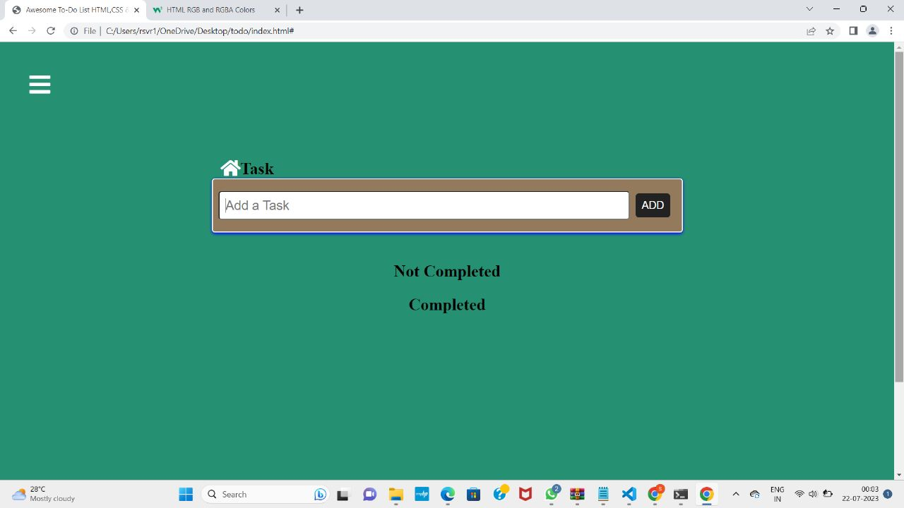

AVANTAGES and disadvantages of todo app

ADVANTAGES OF TODO APP

* Removes clutter from daily or weekly to-do lists
* Provides a place for miscellaneous tasks
* Allows you to prioritize more important tasks
* Having a cleaner, more concise daily to-do list allows you to feel more productive
* These tasks will not be forgotten
* Less waste of time, effort, and ink since constant migration is no longer necessary

DISADVANTAGES OF TODO APP

* Gives you an excuse to remove tasks from your to-do list that you SHOULD do, but CAN put off
* Allows you to avoid these tasks as long as possible
* Promotes procrastination and task avoidance
* A lengthy running to-do list can be intimidating and cluttered

Applications

* It's accessible anywhere and on every device. Browser, Android or IOS it works everywhere You can add images, Audio or you can scribble.
* It allows to add check list, which helps while I go for grocery shopping.
* You can share the notes with anyone else, it makes easy to collaborate.
* It's easy to use, fast and very reliable.
* You can put labels on notes, it makes easy to separate notes from one another

Conclusion

The to-do list developed for this project is meant to be a minimal free and open source application that can help improve the productivity of a user without taking anything.It aims to solve at least some of the problems discussed in the earlier report.

Futurescope

Deviations from expected results and way ahead;

The feature to and list tasks by their priority was implemented towards the end of the project as we had initially planned to classify tasks into

Two lists.